Disruptions in glutamatergic synaptic transmission have been consistently reported in several neurodevelopmental disorders. However, this aspect of their pathophysiology has historically received limited attention due to the heterogeneous nature of these diseases and the current lack of validated biomarkers.

Alterations in tryptophan metabolism have been implicated in various CNS pathologies. One prominent branch of tryptophan metabolism is the kynurenine pathway (KP), which produces both excitotoxic and neuroprotective compounds that act as NMDAR agonists and antagonists respectively. The KP pathway is also linked to energy metabolism through its production of NAD+.

In this study we used targeted metabolomics to find alterations in tryptophan and carbohydrate metabolism in pediatric patients diagnosed with four neurotransmitter disorders with glutamatergic involvement: Rett syndrome, CDKL5-epileptic encephalopathy, GRINopathies, and syntaxin encephalopathy. We grouped patients into hyper- and hypo-glutamatergic cohorts and compared them to age-matched healthy controls.

Tryptophan metabolism impacts glutamatergic neurotransmission through its production of neuroprotective and excitotoxic compounds. Alterations in the balance of these compounds has been implicated in several CNS disorders.

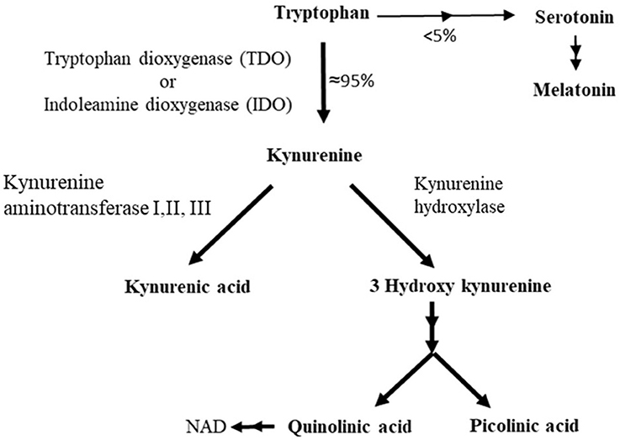

Our study suggests that patients in both cohorts shared metabolic alterations when compared to controls. We identified 25 and 17 altered metabolites in hyper-glutamatergic and hypo-glutamatergic disorders respectively. However, due to the difficulty inherent in obtaining pediatric CSF samples and the rarity of the diseases, this study should be regarded as a preliminary glance into the metabolic alterations involved in these types of neurodevelopmental disorders. Our data could be integrated with that of other future studies in order to increase the sample size and achieve more robust conclusions.